Battle of the Neighborhoods: Tokyo Restaurants and Coffee Shops

By: Jason Robson

Tables of Contents

1. Introduction
2. Data Description
3. Methodology
4. Results
5. Discussion
6. Conclusion

**Introduction**

Kentaro is a financial adviser for Fujitsu and recently moved to an apartment in Tokyo, Japan. Kentaro recently had success in the stock market and wants to leave the telecommunication business. Kentaro wants to open new restaurant or coffee shop in the Tokyo area. If the business is successful, Kentaro plans to leave Fujitsu and devote his time to the new business. Kentaro does not know where to begin. When he walks the streets of Tokyo, he sees all kinds of different restaurants and coffee shops. He wants to develop an idea of what types of restaurants and coffee shops are common in Tokyo’s special wards. Tokyo, Japan has 23 special wards. Kentaro wants to know what ward to open his business and what type of business he should open.

**Data Description**

The type of data selected for Kentaro consists of Tokyo, Japan special wards. This data will be acquired from a Wikipedia page: <https://en.wikipedia.org/wiki/Special_wards_of_Tokyo#List_of_special_wards> Data will be collected on special ward name, population, density, area, and major districts. (Table 1) This information will be used to collect information on the various coffee shops and restaurants in a specific ward using Foursquare. The information will be clustered based on the results. A suggestion will be made whether Kentaro should open a coffee shop or restaurant and where he should open it.

**Table 1. Tokyo, Japan Special Wards.**

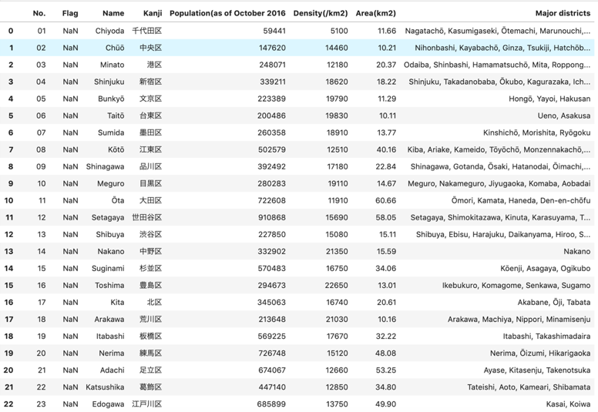

Information on the special wards of Toyko, Japan.

**Methodology**

Table 1 contains more information than is needed to make a conclusion for Kentaro. The data underwent cleaning using Python and Panadas. The flag and Kanji columns were removed. Population, density, and area were renamed. Longitude and Latitude of each special ward was added to the data frame using Geocoders. The result can be seen in Table 2. Foursquare was then used to collect all the venues near Tokyo. The radius was set to 500 and a limit of 100 venues. Foursquare determined there are 31 coffee shops and 45 unique categories of restaurants in the Tokyo area. The mean and frequency were then calculated for all the coffee shops and restaurants. The 45 unique categories of restaurants required further analysis. Foursquare was used to find the top ten most common venues in each special ward. K-means was used to cluster restaurant venue data into clusters based on the similarities (mean) of venue categories. The coordinates of Tokyo, Japan were used to generate a map and the five clusters were assigned to the map.

**Table 2. New Tokyo, Japan Special Wards.**

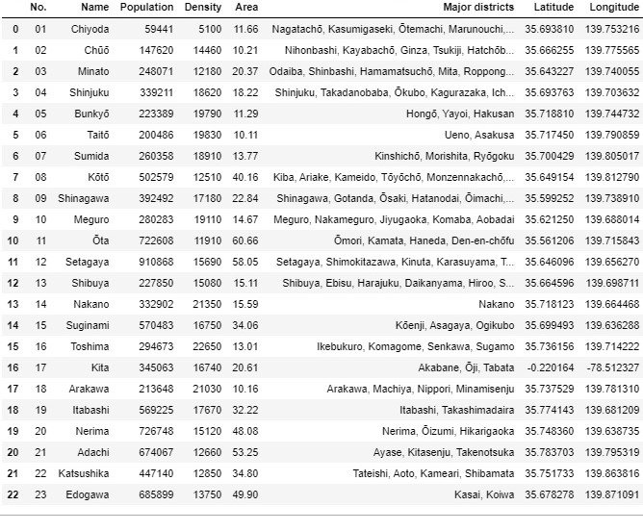Columns adjusted and longitude and latitude added.

**Results**

There are 31 coffee shops and 45 unique categories of restaurants in the Tokyo area. Table 3 shows the coffee shop count for each special ward. Chiyoda, Taitō, Chūō are the top three special wards with the most coffee shops. Table 4 shows the top five restaurant venues by category. Ramen, Japanese, and Chinese make up the top three restaurants by venue. The top three special wards with the most unique restaurants are Chūō with 57, Ōta with 41, and Chiyoda with 31 unique restaurants.

Five clusters were created using K-means (below). Cluster 0 consisted of four special wards: Chūō, Bunkyō, Meguro, and Adachi. The most common venues of Cluster 0 are sushi, Indian, and Chinese restaurants. K-clustering placed 14 special wards into Cluster 1. Ramen, Soba, Japanese, Chinese, and Donburi restaurants were the most common venues. Clusters 2 and 3 got smaller with only two special wards per cluster. Cluster 4 was the smallest with one special ward. All five clusters were mapped to Tokyo, Japan using folium. (Map 1). Each cluster is color coded.

**Table 3. Coffee Shop Count by Special Ward.**

|  |  |
| --- | --- |
| **Special Ward** | **Coffee Shop Count** |
| Chiyoda | 7 |
| Taitō | 6 |
| Chūō | 4 |
| Kita | 3 |
| Shibuya | 3 |
| Katsushika | 2 |
| Meguro | 1 |
| Minato | 1 |
| Nakano | 1 |
| Shinjuku | 1 |
| Suginami | 1 |
| Sumida | 1 |

Coffee shop count by special ward

**Table 4. Top 5 Restaurant Venues.**

|  |  |
| --- | --- |
| **Venue Category** | **Count** |
| Ramen Restaurant | 52 |
| Japanese Restaurant | 45 |
| Chinese Restaurant | 34 |
| Sushi Restaurant | 28 |
| Italian Restaurant | 22 |

Top five restaurant venues by category.

**Cluster 0.**

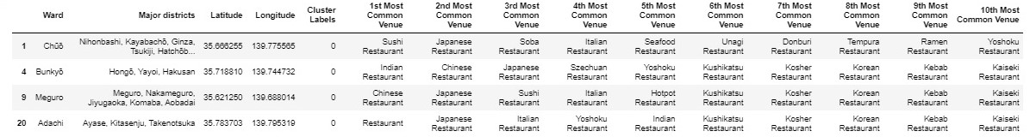

**Cluster 1.**

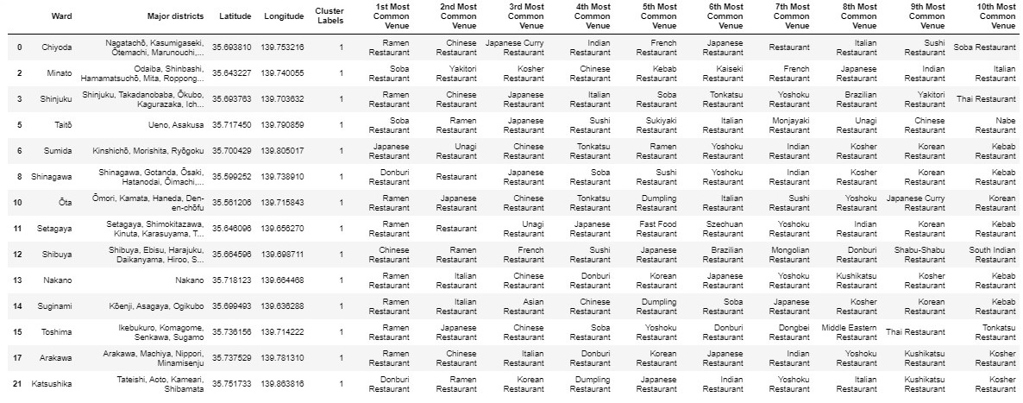

**Cluster 2**.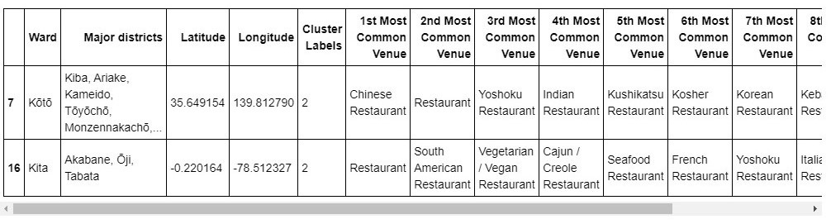

**Cluster 3**.

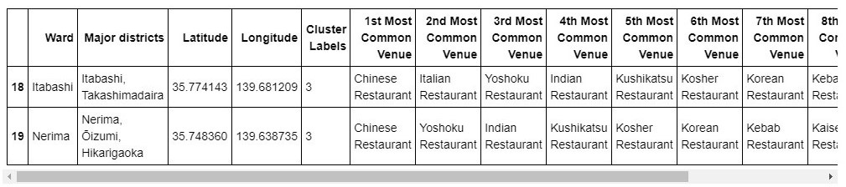

**Cluster 4**.

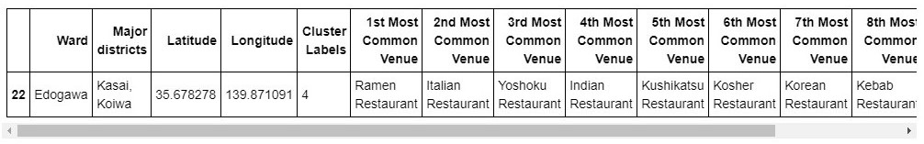

**Map 1. Tokyo, Japan with Restaurant Venue Clusters.**

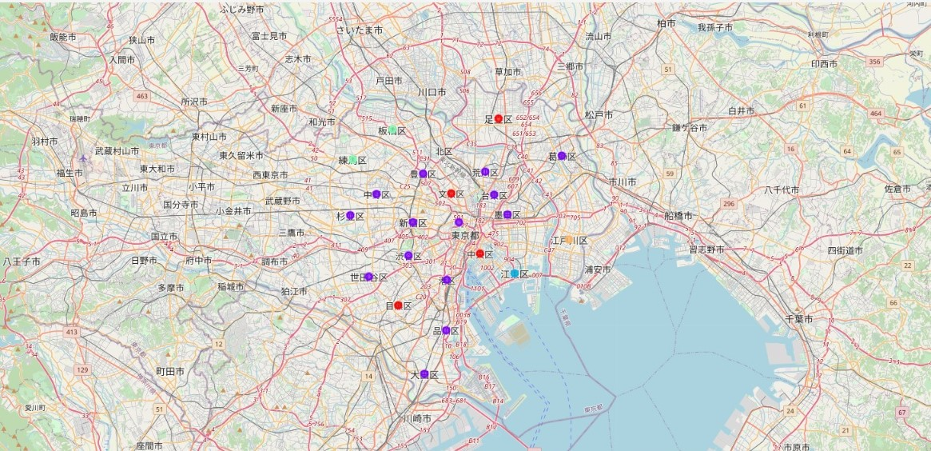

Red= Cluster 0 Purple = Cluster 1 Blue = Cluster 2 Green = Cluster 3 Orange = Cluster 4

**Discussion**

Before bringing it all together, we must remember the business problem. Kentaro wants to open either a coffee shop or a restaurant in Tokyo, Japan. Kentaro does not know what ward to open his business and what type of business he should open. The collected data should be able to answer his questions.

The data shows there are 31 coffee shops in the Tokyo area. The data further shows that there are 45 unique categories of restaurants in the Tokyo area. The initial observation is for Kentaro to open a coffee shop. It is still a developing business venture in Tokyo, Japan. But we need one more piece of data.

Chart 1 details Tokyo, Japan special wards by population. Setagaya has the highest population. Chiyoda has the smallest population. Interestingly, Chiyoda has the smallest population but the most coffee shops at seven. Chiyoda also has 31 unique restaurants. Its most common restaurant venue is Ramen. Chūō has the second smallest population with four coffee shops and 57 unique restaurants. Its most common restaurant venue is sushi. Ōta has 41 unique restaurant venues and the higher population than Chiyoda and Chūō. Its most common restaurant venue is Ramen.

Based on the data, it can be determined that Chiyoda, Chūō, and Ōta special wards are hotspots for food and drink. The data suggests that people migrate from where they live to those three main special wards for food and drink. Chiyoda and Chūō have small populations, but a considerable number of coffee shops and restaurants. Ōta Foursquare data does not show any coffee shops but returns 41 unique restaurants. There is potentially an untapped market in coffee in the Ōta ward.

I would advise Kentaro to investigate opening a coffee shop in Ōta. There is opportunity in that area to grow and develop as a business. If Kentaro decides to open a restaurant, I would suggest opening it in those three main special wards. I would also advise that the restaurant deviate from the common venues of ramen, Japanese, Chinese, and sushi. I would further suggest that qualitative data be collected in those three main special wards. Surveys and one-on-one interviews will help in differentiating his business from others.

**Chart 1. Population of Tokyo, Japan Special Wards.**

Tokyo, Japan special ward populations.

**Conclusion**

Kentaro wanted help in deciding what type of business to open and where. My conclusion, based on the Foursquare data, is for Kentaro to open a coffee shop in Ōta. The special ward has a dense population and a lively restaurant industry. There is potential in opening a coffee shop and differentiating it from other businesses.

If Kentaro decides to open a restaurant, Chiyoda, Chūō, Ōta were determined to be food and drink hotspots. The most common venues in those areas consist of sushi, ramen, Japanese, and Chinese restaurants. My advice to Kentaro would be to avoid opening up those common venues in those areas and to focus on something that differentiates from the common venues.